Step 1: This is the page for running queries with TriNetX, a similar product. I am mostly concerned with the “MUST HAVE”, “CANNOT HAVE”, and Group 1.

MUST HAVE is the terms that our group must include. Think of it as the WHERE = … statement in an SQL Query.

CANNOT HAVE is similar to WHERE != …

Groups are made when you want to make several different groups, and have an AND or OR statement relating the two.

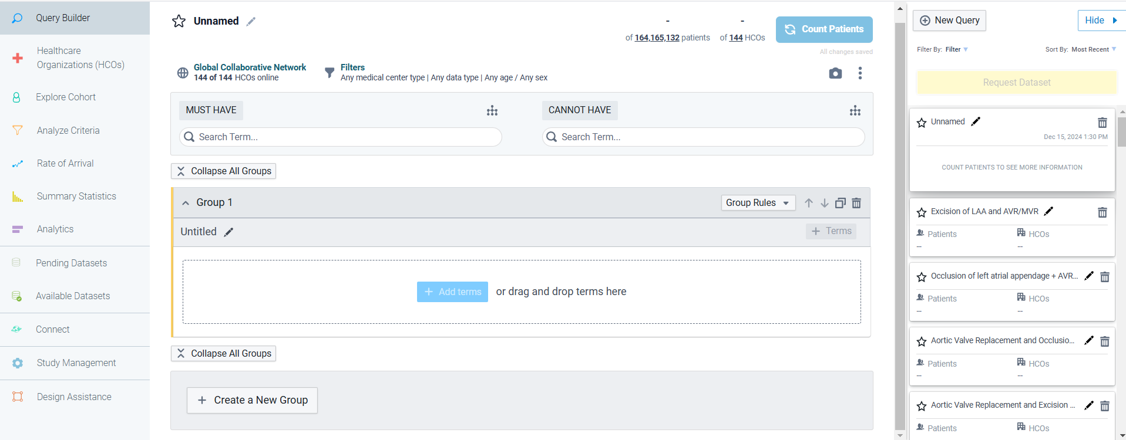

Step 2: I searched for the term “I50” in the “MUST HAVE”, and I was given a suggestion on what it means.

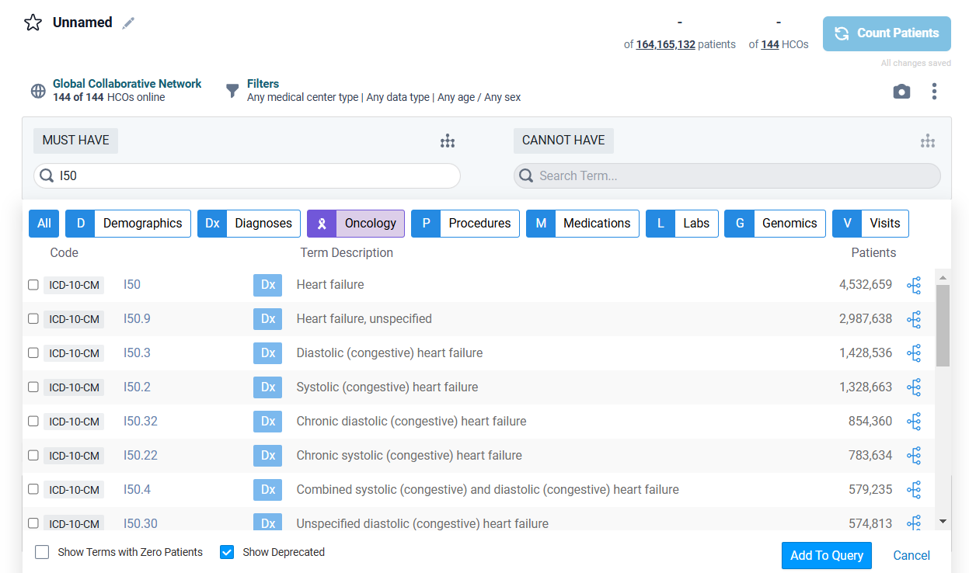

There are dictionaries in the folder that contains the diagnosis codes and what they mean. The icd_version refers to the version of the dictionary- a few years ago we converted from ICD-9 to ICD-10. That probably isn’t necessary to deal with right now, but it would be nice if we could find a way to query both simultaneously.

Page 3

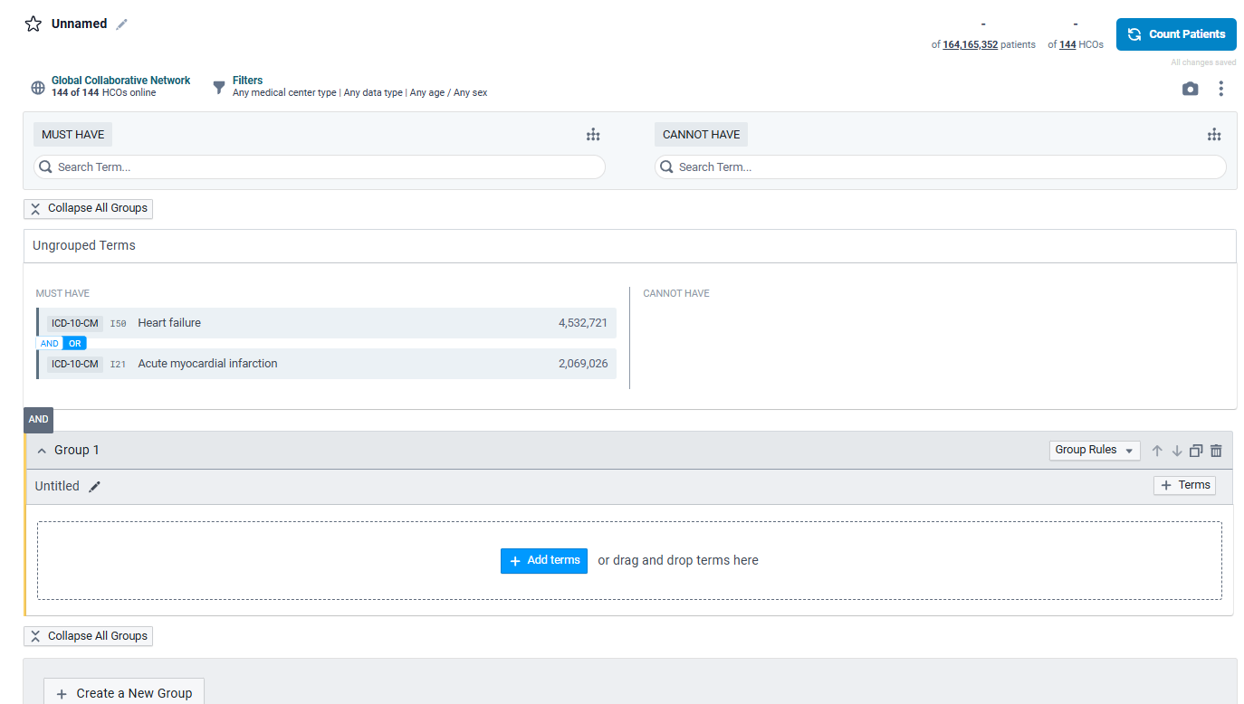

If you enter two diagnoses, you can then choose whether the query will use an AND or OR statement when returning the patients.

Step 3: I am adding another condition/lab value with a continuous range.

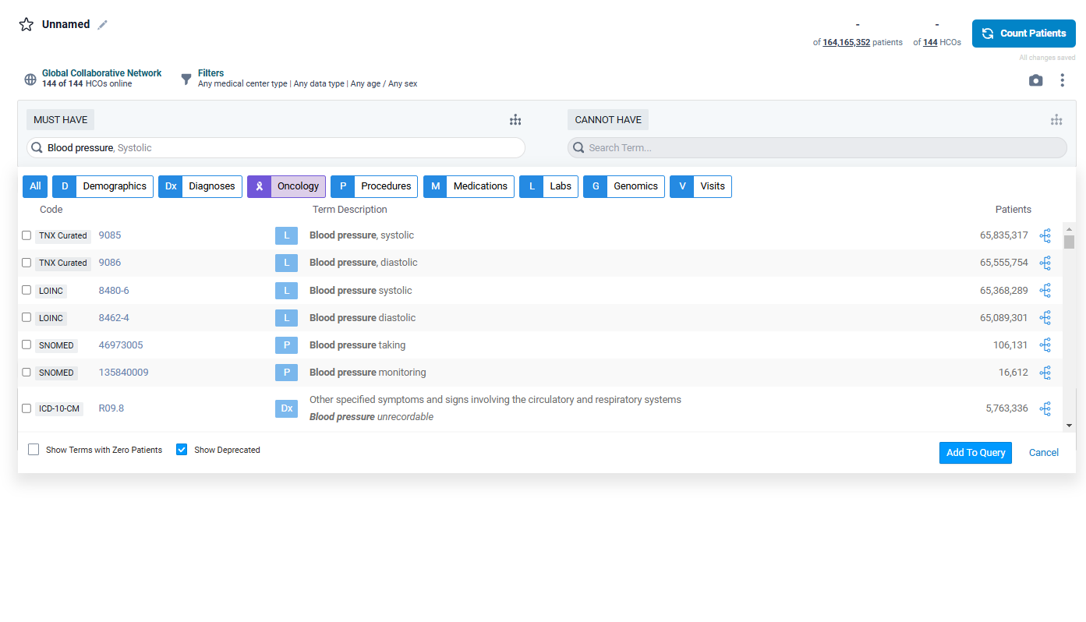

After selecting blood pressure, I am asked to select a range.

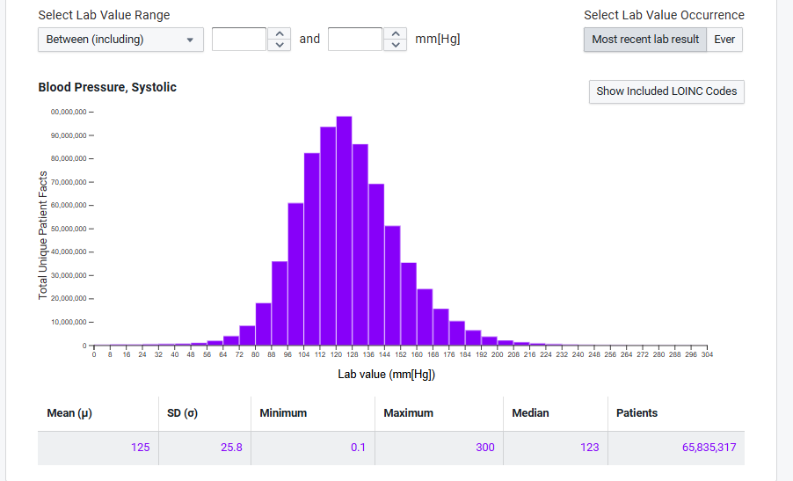

Here is the query now.

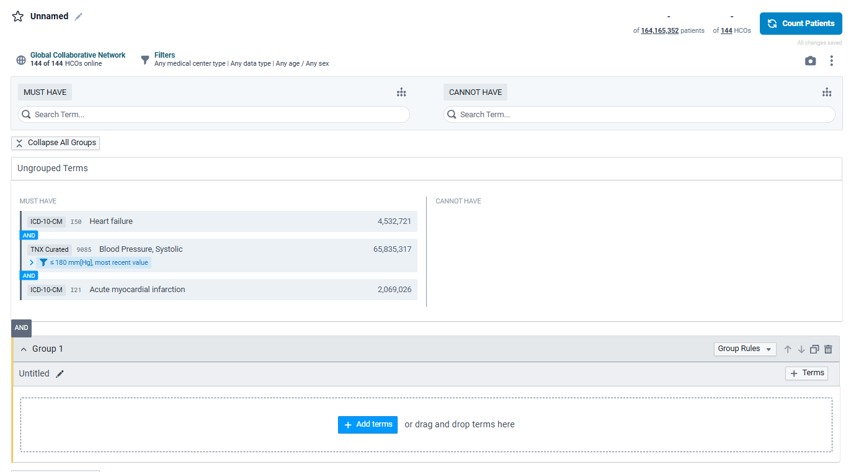

To move the blood pressure to the “CANNOT HAVE”, I just drag-and-dropped it into the other column.

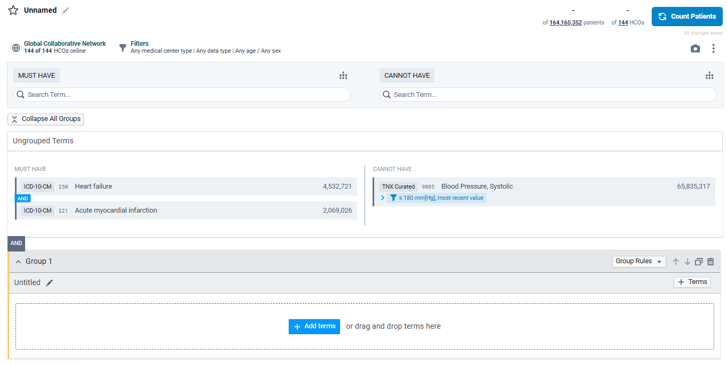

Step 4: Creating a new group. I just drag and dropped all the conditions into a group.

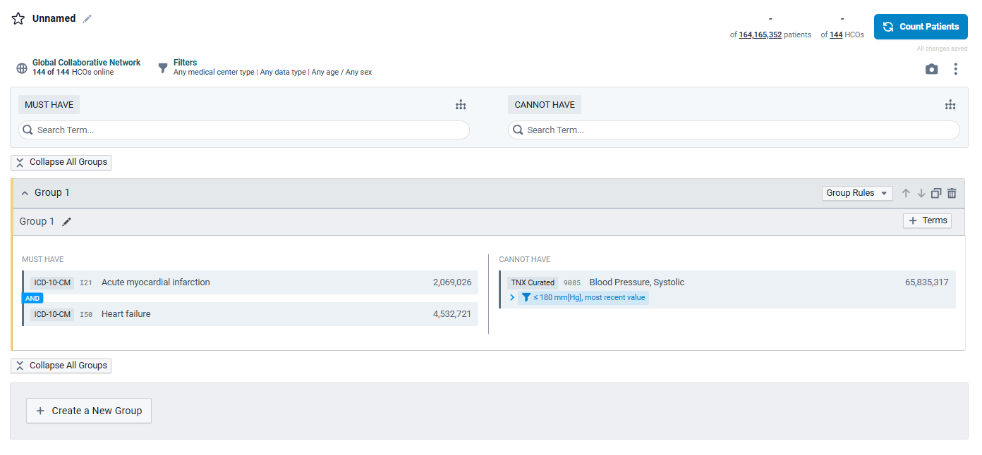

If I hit “Create a new group”, I get this:

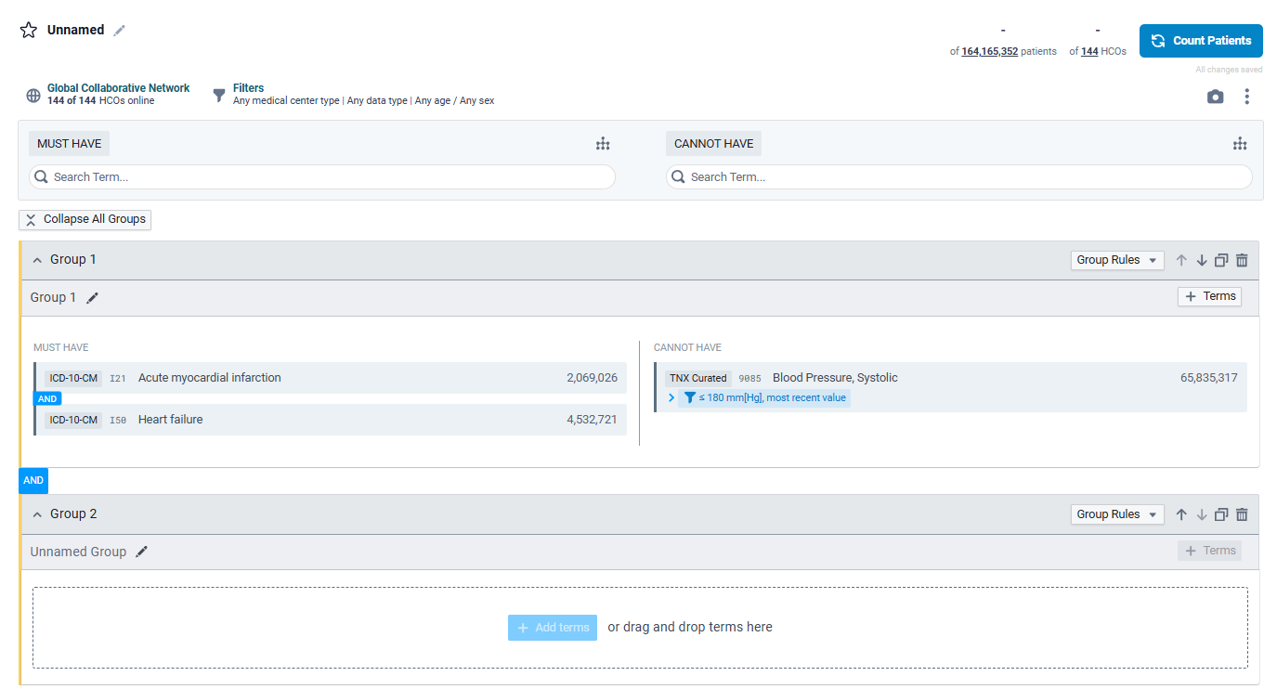

Same steps to create a query as before.

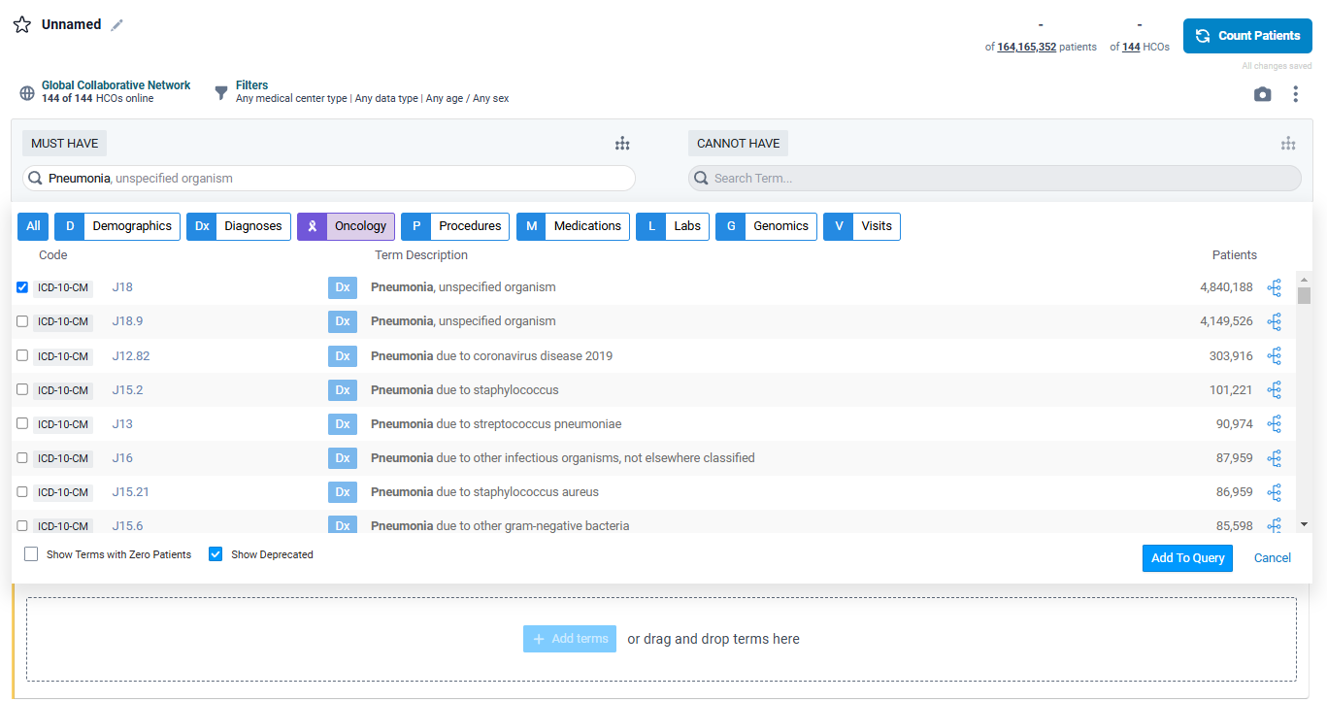

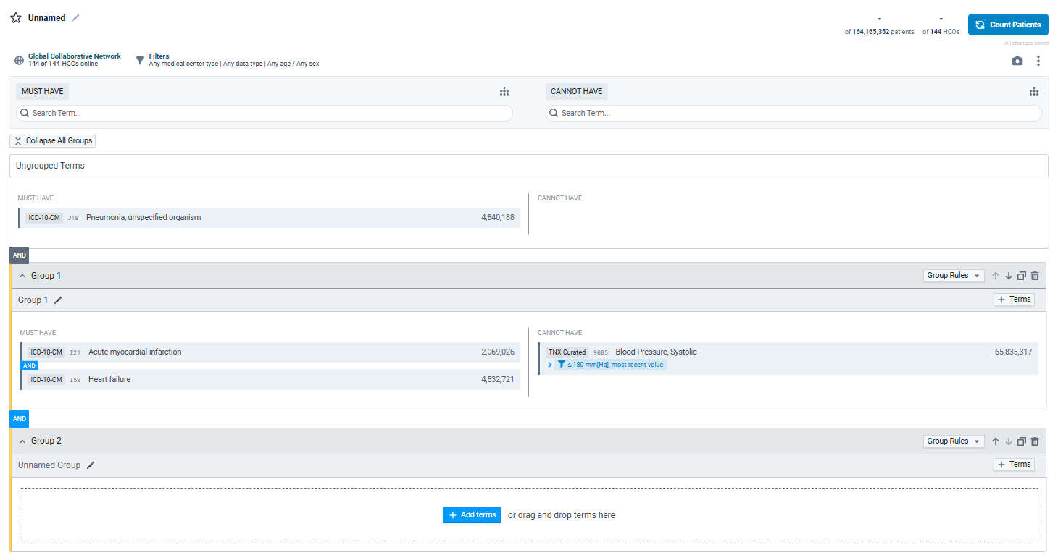

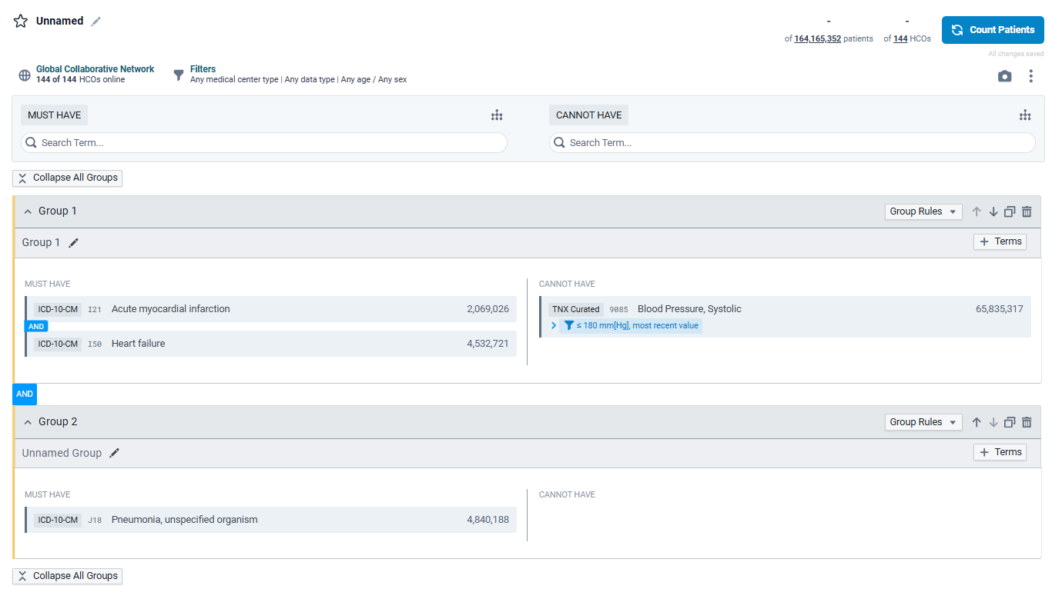

However, note that between the two groups, there is an AND statement. That should be a toggle-able AND or OR statement.

Page 5: Have a panel that allows people to return certain variables (diagnoses, lab values, medications, etc).

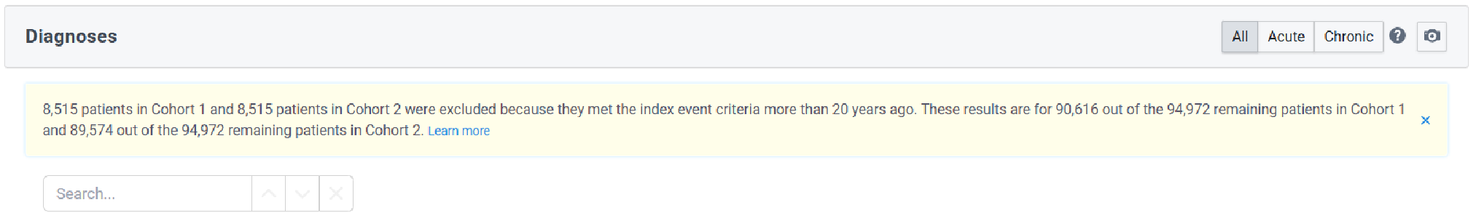

Step 6: If I hit the button “Count Patients”, it should return all the patients who fulfill these conditions, and the variables that were selected in Step 5.



Step 7: Previously, I’ve been generating a list of subject_id and hadm_id based on the diagnoses codes, and then using the codes and the table in [All Variables in folders](https://docs.google.com/spreadsheets/d/1en0cs47NaTEuy0bqHbk00sbCWDzSLmQ0/edit?usp=drive_link&ouid=111676192130285504391&rtpof=true&sd=true) to extract variables of interest, but I don’t know if that is modular enough to use for our project.

In my computer, the path to the folder with the diagnosis codes is:  
C:\Users\steve\Documents\MIMIC IV ED.ICU.Hosp\**mimic-iv-3.1\mimic-iv-3.1\hosp\d_icd_diagnoses.csv.gz**

The path to the folder with the procedure codes is

C:\Users\steve\Documents\MIMIC IV ED.ICU.Hosp\**mimic-iv-3.1\mimic-iv-3.1\hosp\d_icd_procedures.csv.gz**

I’m unsure of whether we will use the diagnosis related groups (drg) codes.

The path to the diagnosis related groups is:

C:\Users\steve\Documents\MIMIC IV ED.ICU.Hosp\**mimic-iv-3.1\mimic-iv-3.1\hosp\drgcodes.csv.gz**

Step 8: Patient matching would be nice, but we can worry about that later.